Hướng dẫn giải bài tập Ôn tập 1

Giao diện chương trình:
Giao diện chính:
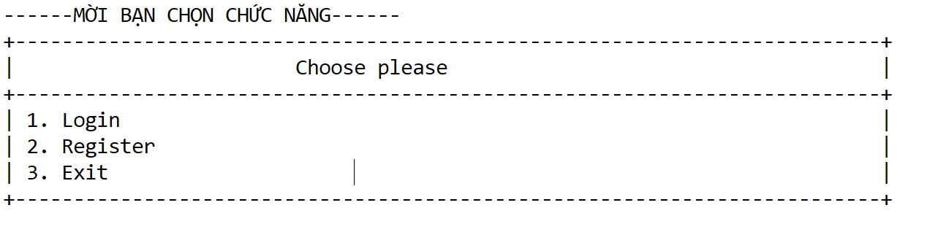
Giao diện login:
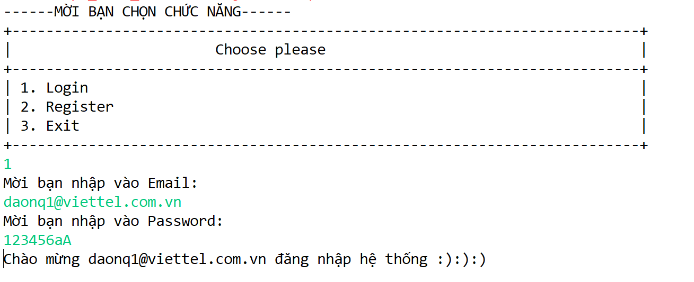
Giao diện Register:
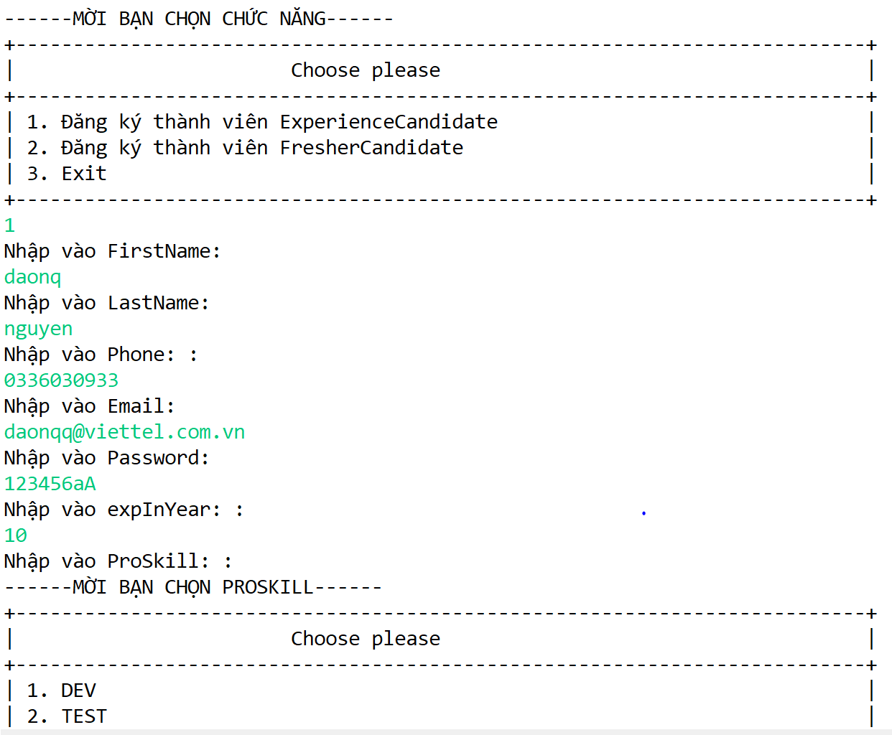
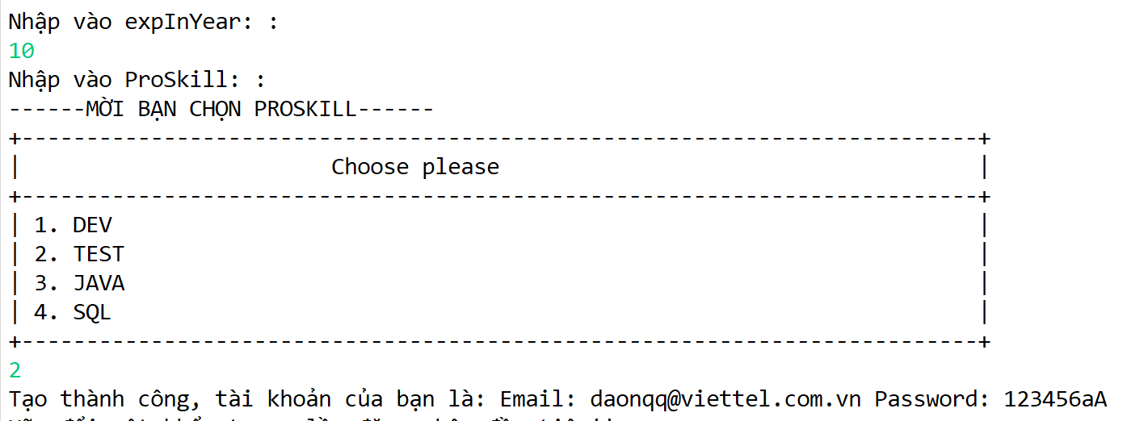

Tạo khung chương trình:
Tạo mới 1 project: VTI_TesttingSystem_Assignment_12_JV1_EX_DNQ
Tạo các Package trong src: com.vti.backend, com.vti.entiy, com.vti.frontend, com.vti.utils
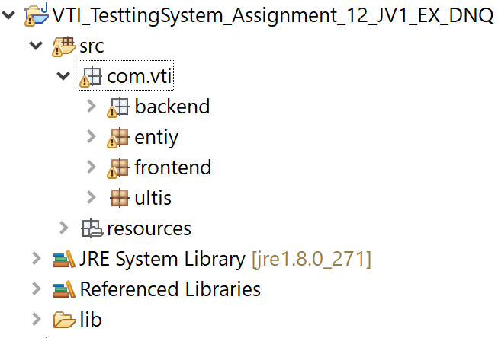
Trong backend tạo lần lượt các package: com.vti.backend.businesslayer, com.vti.backend.datalayer, com.vti.backend.presentationlayer
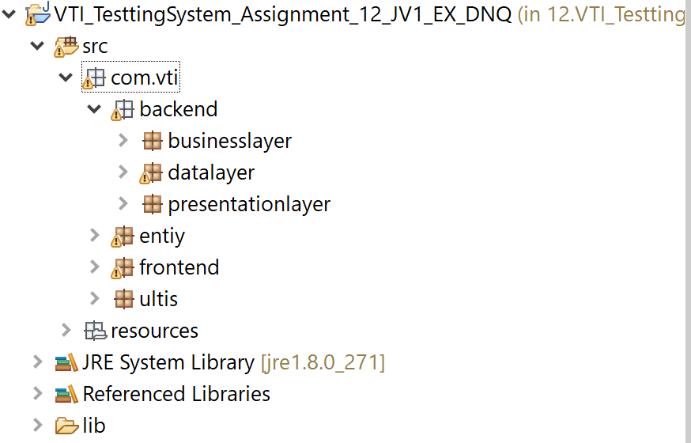
Tạo Package com.vti.resources:
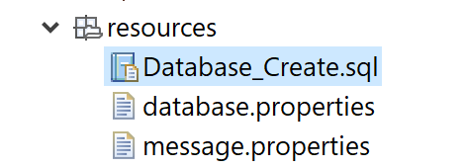
Tạo file: database.properties
# -----------------------
# database information
# -----------------------
url = jdbc:mysql://localhost:3306/TestingSystem_EX1?autoReconnect=true&useSSL=false&characterEncoding=latin1
username = root
password = root
driver = com.mysql.cj.jdbc.Driver
Tạo file: Database_Create.sql

Tạo Class JdbcUltis trong package ultis:

package com.vti.ultis;

import java.io.FileInputStream;
import java.io.FileNotFoundException;
import java.io.IOException;
import java.sql.Connection;
import java.sql.DriverManager;
import java.sql.PreparedStatement;
import java.sql.ResultSet;
import java.sql.SQLException;
import java.sql.Statement;
import java.util.Properties;

public class jdbcUltis {
private Properties property;
private Connection connection;

public jdbcUltis() throws FileNotFoundException, IOException {
property = new Properties();
property.load(new FileInputStream("G:\\My Drive\\DNQ_VTI\\2. JAVA CORE\\DAONQ_TL\\Source Code\\TestingSystem\\12.VTI_TesttingSystem_Assignment_12_JV1_EX_DNQ\\src\\resources\\database.properties"));
}

public void connnectionTestting() throws ClassNotFoundException, SQLException {
String url = property.getProperty("url");
String Username = property.getProperty("username");
String password = property.getProperty("password");
String dirver = property.getProperty("driver");

Class.forName(dirver);
connection = DriverManager.getConnection(url, Username, password);
System.out.println("Connect Success");
}

public Connection getConnection() throws ClassNotFoundException, SQLException {
String url = property.getProperty("url");
String Username = property.getProperty("username");
String password = property.getProperty("password");
String dirver = property.getProperty("driver");
Class.forName(dirver);
connection = DriverManager.getConnection(url, Username, password);
return connection;
}

public void disConnection() throws SQLException {
connection.close();
}

public ResultSet executeQuery(String sql) throws ClassNotFoundException, SQLException {
Connection connnection = getConnection();
Statement statement = connnection.createStatement();
ResultSet result = statement.executeQuery(sql);
return result;
}

public PreparedStatement createPrepareStatement(String sql) throws ClassNotFoundException, SQLException {
Connection connnection = getConnection();
PreparedStatement preStatement = connnection.prepareStatement(sql);
return preStatement;
}

}

Tạo Class ScannerUltis trong package ultis:
package com.vti.ultis;

import java.text.SimpleDateFormat;
import java.time.LocalDate;
import java.util.Scanner;

public class ScannerUltis {
private static Scanner sc = new Scanner(System.in);

public static int inputInt() {
while (true) {
try {
return Integer.parseInt(sc.next().trim());
} catch (Exception e) {
System.err.println("Nhập lại:");
}
}
}

public static int inputIntPositive() {
while (true) {
try {
int intPositive = Integer.parseInt(sc.next());
if (intPositive >= 0) {
return intPositive;
} else {
System.err.println("Nhập lại:");
}

} catch (Exception e) {
System.err.println("Nhập lại:");
}

}
}

public static Float inputFloat() {
while (true) {
try {
return Float.parseFloat(sc.next());
} catch (Exception e) {
System.err.println("Nhập lại:");
}
}
}

public static Double inputDouble() {
while (true) {
try {
return Double.parseDouble(sc.next());
} catch (Exception e) {
System.err.println("Nhập lại:");
}
}
}

public static String inputString() {
while (true) {
String string = sc.next().trim();
if (!string.isEmpty()) {
return string;
} else {
System.err.println("Nhập lại:");
}
}
}

public static LocalDate inputLocalDate() {
System.out.println("Nhập theo định dạng yyyy-MM-dd");
SimpleDateFormat format = new SimpleDateFormat("yyyy-MM-dd");
while (true) {
String localdate = sc.next().trim();
try {
if (format.parse(localdate) != null) {
LocalDate lc = LocalDate.parse(localdate);
return lc;
}
} catch (Exception e) {
System.err.println("Nhập lại:");
}

}
}

public static String inputEmail() {
while (true) {
String email = ScannerUltis.inputString();
if (email == null || !email.contains("@")) {
System.out.print("Nhập lại: ");
} else {
return email;
}
}
}

public static int inputFunction(int a, int b, String errorMessage) {
while (true) {
int number = ScannerUltis.inputInt();
if (number >= a && number <= b) {
return number;
} else {
System.err.println(errorMessage);
}
}
}

public static String inputPassword() {
while (true) {
String password = ScannerUltis.inputString();
if (password.length() < 6 || password.length() > 12) {
System.out.print("Nhập lại: ");
continue;
}

boolean hasAtLeast1Character = false;

for (int i = 0; i < password.length(); i++) {
if (Character.isUpperCase(password.charAt(i)) == true) {
hasAtLeast1Character = true;
break;
}
}
if (hasAtLeast1Character == true) {
return password;
} else {
System.out.print("Mời bạn nhập lại password: ");
}
}
}

public static String inputPhoneNumber() {
while (true) {
String number = ScannerUltis.inputString();
if (number.length() > 12 || number.length() < 9) {
continue;
}

if (number.charAt(0) != '0') {
continue;
}

boolean isNumber = true;

for (int i = 0; i < number.length(); i++) {
if (Character.isDigit(number.charAt(i)) == false) {
isNumber = false;
break;
}
}
if (isNumber == true) {
return number;
} else {
System.out.print("Nhập lại: ");
}

}
}

}

Tạo Class Candidate trong Entity:

package com.vti.entiy;

public class Candidate {
private int id;
private String firstName;
private String lastName;
private String phone;
private String email;
private String password;

private Category category;

public Candidate(String firstName, String lastName, String phone, String email, String password,
Category category) {
this.firstName = firstName;
this.lastName = lastName;
this.phone = phone;
this.email = email;
this.password = password;
this.category = category;
}

public enum Category {
EXPERIENCECANDIDATE, FRESHERCANDIDATE
}
}

Tạo Class ExperienceCandidate trong Entity:

package com.vti.entiy;

public class ExperienceCandidate extends Candidate {

private int expInYear;
private ProSkill proSkill;

public enum ProSkill {
DEV, TEST, JAVA, SQL
}

public ExperienceCandidate(String firstName, String lastName, String phone, String email, String password,
Category category, int expInYear, ProSkill proSkill) {
super(firstName, lastName, phone, email, password, category);
this.expInYear = expInYear;
this.proSkill = proSkill;
}

}

Tạo Class FresherCandidate trong Entity:
package com.vti.entiy;

public class FresherCandidate extends Candidate {
private GraduationRank graduationRank;

public enum GraduationRank {
EXCELLENCE, GOOD, FAIR, POOR
}

public FresherCandidate(String firstName, String lastName, String phone, String email, String password,
Category category, GraduationRank graduationRank) {
super(firstName, lastName, phone, email, password, category);
this.graduationRank = graduationRank;
}

}

Tạo Interface ICandidateRepository trong datalayer:
package com.vti.backend.datalayer;

import java.sql.SQLException;

import com.vti.entiy.Candidate;
import com.vti.entiy.ExperienceCandidate.ProSkill;
import com.vti.entiy.FresherCandidate.GraduationRank;

public interface ICandidateRepository {

boolean isCandidateIdExits(String email) throws SQLException, ClassNotFoundException;

public Boolean loginCandidate(String email, String password) throws SQLException, ClassNotFoundException;

public boolean createExperienceCandidate(String firstName, String lastName, String phone, String email,
String password, int expInYear, ProSkill ProSkill) throws SQLException, ClassNotFoundException;

public boolean createFresherCandidate(String firstName, String lastName, String phone, String email,
String password, GraduationRank graduationRank) throws SQLException, ClassNotFoundException;
}

Tạo Class CandidateRepository trong datalayer:
package com.vti.backend.datalayer;

import java.io.FileNotFoundException;
import java.io.IOException;
import java.sql.PreparedStatement;
import java.sql.ResultSet;
import java.sql.SQLException;

import com.vti.entiy.Candidate;
import com.vti.entiy.ExperienceCandidate.ProSkill;
import com.vti.entiy.FresherCandidate.GraduationRank;
import com.vti.ultis.jdbcUltis;

public class CandidateRepository implements ICandidateRepository {
private jdbcUltis jdbc;

public CandidateRepository() throws FileNotFoundException, IOException {
jdbc = new jdbcUltis();
}

@Override
public boolean isCandidateIdExits(String email) throws SQLException, ClassNotFoundException {
String sql = "SELECT * FROM candidate c WHERE c.Email = ?";
PreparedStatement preStatement = jdbc.createPrepareStatement(sql);
preStatement.setNString(1, email);
ResultSet result = preStatement.executeQuery();

if (result.next()) {
jdbc.disConnection();
return true;
} else {
jdbc.disConnection();
return false;
}
}

@Override
public Boolean loginCandidate(String email, String password) throws SQLException, ClassNotFoundException {
String sql = "SELECT * FROM candidate c WHERE c.Email = ? AND c.password =?;";
PreparedStatement preStatement = jdbc.createPrepareStatement(sql);
preStatement.setString(1, email);
preStatement.setString(2, password);
ResultSet resultSet = preStatement.executeQuery();
if (resultSet.next()) {
return true;
} else {
return false;
}

}

@Override
public boolean createExperienceCandidate(String firstName, String lastName, String phone, String email,
String password, int expInYear, ProSkill ProSkill) throws SQLException, ClassNotFoundException {
String sql = "INSERT INTO `candidate` (`FirstName`, `LastName`, `Phone`, `Email`, `password`, `expInYear`, `ProSkill`, `Category`)\r\n"
+ "VALUES (?, ?, ?, ?, ?, ?, ?, 'ExperienceCandidate');";

PreparedStatement preStatement = jdbc.createPrepareStatement(sql);
preStatement.setNString(1, firstName);
preStatement.setNString(2, lastName);
preStatement.setNString(3, phone);
preStatement.setString(4, email);
preStatement.setString(5, password);
preStatement.setInt(6, expInYear);
preStatement.setNString(7, ProSkill.toString());
int result = preStatement.executeUpdate();
if (result == 1) {
jdbc.disConnection();
return true;
} else {
jdbc.disConnection();
return false;
}
}

@Override
public boolean createFresherCandidate(String firstName, String lastName, String phone, String email,
String password, GraduationRank graduationRank) throws SQLException, ClassNotFoundException {

String sql = "INSERT INTO `candidate` (`FirstName`, `LastName`, `Phone`, `Email`, `password`, `GraduationRank`, `Category` )\r\n"
+ "VALUES (?, ?, ?, ?, ?, ?, 'FresherCandidate');\r\n"
+ "";

PreparedStatement preStatement = jdbc.createPrepareStatement(sql);
preStatement.setNString(1, firstName);
preStatement.setNString(2, lastName);
preStatement.setNString(3, phone);
preStatement.setString(4, email);
preStatement.setString(5, password);
preStatement.setString(6, graduationRank.toString());
int result = preStatement.executeUpdate();
if (result == 1) {
jdbc.disConnection();
return true;
} else {
jdbc.disConnection();
return false;
}
}

}

Tạo Interface ICandidateService trong businesslayer:
package com.vti.backend.businesslayer;

import java.sql.SQLException;

import com.vti.entiy.ExperienceCandidate.ProSkill;
import com.vti.entiy.FresherCandidate.GraduationRank;

public interface ICandidateService {
public boolean createExperienceCandidate(String firstName, String lastName, String phone, String email,
String password, int expInYear, ProSkill ProSkill) throws SQLException, ClassNotFoundException;

public Boolean loginCandidate(String email, String password) throws SQLException, ClassNotFoundException;

public boolean createFresherCandidate(String firstName, String lastName, String phone, String email,
String password, GraduationRank graduationRank) throws SQLException, ClassNotFoundException;

public boolean isCandidateIdExits(String email) throws SQLException, ClassNotFoundException;
}

Tạo Class CandidateService trong businesslayer:
package com.vti.backend.businesslayer;

import java.io.FileNotFoundException;
import java.io.IOException;
import java.sql.SQLException;

import com.vti.backend.datalayer.CandidateRepository;
import com.vti.backend.datalayer.ICandidateRepository;
import com.vti.entiy.ExperienceCandidate.ProSkill;
import com.vti.entiy.FresherCandidate.GraduationRank;

public class CandidateService implements ICandidateService {

private ICandidateRepository candidateRepository;

public CandidateService() throws FileNotFoundException, IOException {
candidateRepository = new CandidateRepository();
}

@Override
public boolean createExperienceCandidate(String firstName, String lastName, String phone, String email,
String password, int expInYear, ProSkill ProSkill) throws SQLException, ClassNotFoundException {
// TODO Auto-generated method stub
return candidateRepository.createExperienceCandidate(firstName, lastName, phone, email, password, expInYear, ProSkill);
}

@Override
public boolean createFresherCandidate(String firstName, String lastName, String phone, String email,
String password, GraduationRank graduationRank) throws SQLException, ClassNotFoundException {
// TODO Auto-generated method stub
return candidateRepository.createFresherCandidate(firstName, lastName, phone, email, password, graduationRank);
}

@Override
public boolean isCandidateIdExits(String email) throws SQLException, ClassNotFoundException {
// TODO Auto-generated method stub
return candidateRepository.isCandidateIdExits(email);
}

@Override
public Boolean loginCandidate(String email, String password) throws SQLException, ClassNotFoundException {
// TODO Auto-generated method stub
return candidateRepository.loginCandidate(email, password);
}

}

Tạo Class CandidateController trong presentationlayer:
package com.vti.backend.presentationlayer;

import java.io.FileNotFoundException;
import java.io.IOException;
import java.sql.SQLException;

import com.vti.backend.businesslayer.CandidateService;
import com.vti.backend.businesslayer.ICandidateService;
import com.vti.entiy.ExperienceCandidate.ProSkill;
import com.vti.entiy.FresherCandidate.GraduationRank;

public class CandidateController {
private ICandidateService candidateService;

public CandidateController() throws FileNotFoundException, IOException {
candidateService = new CandidateService();
}

public boolean createExperienceCandidate(String firstName, String lastName, String phone, String email,
String password, int expInYear, ProSkill ProSkill) throws SQLException, ClassNotFoundException {

return candidateService.createExperienceCandidate(firstName, lastName, phone, email, password, expInYear,
ProSkill);
}

public boolean createFresherCandidate(String firstName, String lastName, String phone, String email,
String password, GraduationRank graduationRank) throws SQLException, ClassNotFoundException {

return candidateService.createFresherCandidate(firstName, lastName, phone, email, password, graduationRank);
}

public boolean isCandidateIdExits(String email) throws SQLException, ClassNotFoundException {

return candidateService.isCandidateIdExits(email);

}

public Boolean loginCandidate(String email, String password) throws SQLException, ClassNotFoundException {

return candidateService.loginCandidate(email, password);
}

}

Tạo Class Function Frontend:
package com.vti.frontend;

import java.io.FileNotFoundException;
import java.io.IOException;
import java.sql.SQLException;

import com.sun.org.apache.bcel.internal.generic.RETURN;
import com.vti.backend.presentationlayer.CandidateController;
import com.vti.entiy.ExperienceCandidate.ProSkill;
import com.vti.entiy.FresherCandidate.GraduationRank;
import com.vti.ultis.ScannerUltis;

public class Function {
private CandidateController candidateControler;

public Function() throws FileNotFoundException, IOException {
candidateControler = new CandidateController();
}

public void getRegister() throws ClassNotFoundException, SQLException {
while (true) {
System.out.println("------MỜI BẠN CHỌN CHỨC NĂNG------");
String leftAlignFormat = "| %-72s |%n";
System.out.format("+--------------------------------------------------------------------------+%n");
System.out.format("| Choose please |%n");
System.out.format("+--------------------------------------------------------------------------+%n");
System.out.format(leftAlignFormat, "1. Đăng ký thành viên ExperienceCandidate");
System.out.format(leftAlignFormat, "2. Đăng ký thành viên FresherCandidate");
System.out.format(leftAlignFormat, "3. Exit");
System.out.format("+--------------------------------------------------------------------------+%n");
switch (ScannerUltis.inputIntPositive()) {
case 1:
System.out.println("Nhập vào FirstName: ");
String firstName = ScannerUltis.inputString();
System.out.println("Nhập vào LastName: ");
String lastName = ScannerUltis.inputString();
System.out.println("Nhập vào Phone: : ");
String phone = ScannerUltis.inputPhoneNumber();
System.out.println("Nhập vào Email: ");
String email = ScannerUltis.inputEmail();
if (candidateControler.isCandidateIdExits(email)) {
System.out.println("Đã tồn tại Account này trên hệ thống");
break;
}
System.out.println("Nhập vào Password: ");
String password = ScannerUltis.inputPassword();
System.out.println("Nhập vào expInYear: : ");
int expInYear = ScannerUltis.inputIntPositive();
System.out.println("Nhập vào ProSkill: : ");
ProSkill proSkill = getproSkill();
Boolean flag = candidateControler.createExperienceCandidate(firstName, lastName, phone, email, password,
expInYear, proSkill);
if (flag) {
System.out.println(
"Tạo thành công, tài khoản của bạn là: Email: " + email + " Password: " + password);
System.out.println("Hãy đổi mật khẩu trong lần đăng nhập đầu tiên!!");
return;
} else {
System.out.println("Tạo không thành công, hãy kiểm tra lại");
break;
}

case 2:
System.out.println("Nhập vào FirstName: ");
String firstName1 = ScannerUltis.inputString();
System.out.println("Nhập vào LastName: ");
String lastName1 = ScannerUltis.inputString();
System.out.println("Nhập vào Phone: : ");
String phone1 = ScannerUltis.inputPhoneNumber();
System.out.println("Nhập vào Email: ");
String email1 = ScannerUltis.inputEmail();
if (candidateControler.isCandidateIdExits(email1)) {
System.out.println("Đã tồn tại Account này trên hệ thống");
break;
}
System.out.println("Nhập vào Password: ");
String password1 = ScannerUltis.inputPassword();
System.out.println("Nhập vào GraduationRank: : ");
GraduationRank graduationRank = getGraduationRank();
Boolean flag1 = candidateControler.createFresherCandidate(firstName1, lastName1, phone1, email1,
password1, graduationRank);
if (flag1) {
System.out.println(
"Tạo thành công, tài khoản của bạn là: Email: " + email1 + " Password: " + password1);
System.out.println("Hãy đổi mật khẩu trong lần đăng nhập đầu tiên!!");
return;
} else {
System.out.println("Tạo không thành công, hãy kiểm tra lại");
break;
}
case 3:

return;
default:
System.out.println("Nhập lại:");
break;
}
}

}

private ProSkill getproSkill() {

while (true) {
System.out.println("------MỜI BẠN CHỌN PROSKILL------");
String leftAlignFormat = "| %-72s |%n";
System.out.format("+--------------------------------------------------------------------------+%n");
System.out.format("| Choose please |%n");
System.out.format("+--------------------------------------------------------------------------+%n");
System.out.format(leftAlignFormat, "1. DEV");
System.out.format(leftAlignFormat, "2. TEST");
System.out.format(leftAlignFormat, "3. JAVA");
System.out.format(leftAlignFormat, "4. SQL");
System.out.format("+--------------------------------------------------------------------------+%n");
switch (ScannerUltis.inputIntPositive()) {
case 1:

return ProSkill.DEV;
case 2:

return ProSkill.TEST;
case 3:

return ProSkill.JAVA;
case 4:

return ProSkill.SQL;
default:
System.out.println("Nhập lại:");
break;

}
}
}

private GraduationRank getGraduationRank() {
while (true) {
System.out.println("------MỜI BẠN CHỌN GRADUATIONRANK------");
String leftAlignFormat = "| %-72s |%n";
System.out.format("+--------------------------------------------------------------------------+%n");
System.out.format("| Choose please |%n");
System.out.format("+--------------------------------------------------------------------------+%n");
System.out.format(leftAlignFormat, "1. EXCELLENCE");
System.out.format(leftAlignFormat, "2. GOOD");
System.out.format(leftAlignFormat, "3. FAIR");
System.out.format(leftAlignFormat, "4. POOR");
System.out.format("+--------------------------------------------------------------------------+%n");
switch (ScannerUltis.inputIntPositive()) {
case 1:

return GraduationRank.EXCELLENCE;
case 2:

return GraduationRank.GOOD;
case 3:

return GraduationRank.FAIR;
case 4:

return GraduationRank.POOR;
default:
System.out.println("Nhập lại:");
break;

}
}
}

public void getLogin() throws ClassNotFoundException, SQLException {
System.out.println("Mời bạn nhập vào Email: ");
String email = ScannerUltis.inputEmail();
System.out.println("Mời bạn nhập vào Password: ");
String pass = ScannerUltis.inputPassword();
if (candidateControler.loginCandidate(email, pass)) {
System.out.println("Chào mừng " + email + " đăng nhập hệ thống :):):)");
System.out.println();
System.out.println();
} else {
System.out.println("Tài khoản không chính xác");
return;
}

}
}

Tạo Class Demo:
package com.vti.frontend;

import java.io.FileNotFoundException;
import java.io.IOException;
import java.sql.SQLException;

import com.vti.ultis.ScannerUltis;
import com.vti.ultis.jdbcUltis;

public class Demo {
public static void main(String[] args)
throws FileNotFoundException, IOException, ClassNotFoundException, SQLException {
Function function = new Function();
while (true) {
while (true) {
System.out.println("------MỜI BẠN CHỌN CHỨC NĂNG------");
String leftAlignFormat = "| %-72s |%n";
System.out.format("+--------------------------------------------------------------------------+%n");
System.out.format("| Choose please |%n");
System.out.format("+--------------------------------------------------------------------------+%n");
System.out.format(leftAlignFormat, "1. Login");
System.out.format(leftAlignFormat, "2. Register");
System.out.format(leftAlignFormat, "3. Exit");
System.out.format("+--------------------------------------------------------------------------+%n");
switch (ScannerUltis.inputIntPositive()) {
case 1:
function.getLogin();
break;
case 2:
function.getRegister();

break;
case 3:

return;
default:
System.out.println("Nhập lại:");
break;
}
}
}
}
}

